**DBMS Laboratory**

**UE19CS304**

**5th Semester, Academic Year 2021-22**

Week #: 1 - CRUD Operations on MongoDB

Date: 15/9/2021

|  |  |  |
| --- | --- | --- |
| Name :  SUMUKH RAJU BHAT | SRN :  PES1UG19CS519 | Section :  H |

1. **CREATE:**
2. Insert a record into the database using insert(record). As the database doesn’t exist, it create a db named “students” and inserts the record

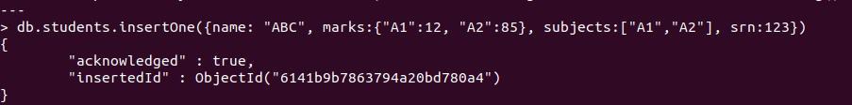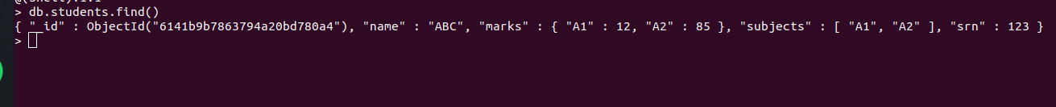

1. Insert 3 records in the db using insertMany([records])

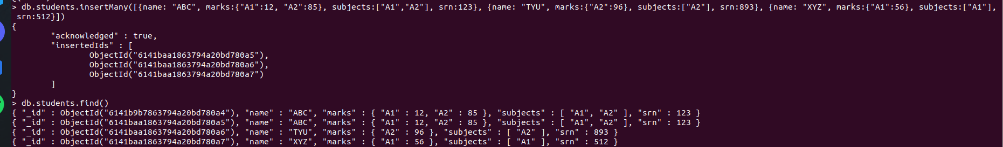

1. **READ:**
2. Display the records in the database using find() method

- find() gives us all the records and find(filter) gives us all the records matching the filter and findOne(filter) gives us just one record matching the filter.

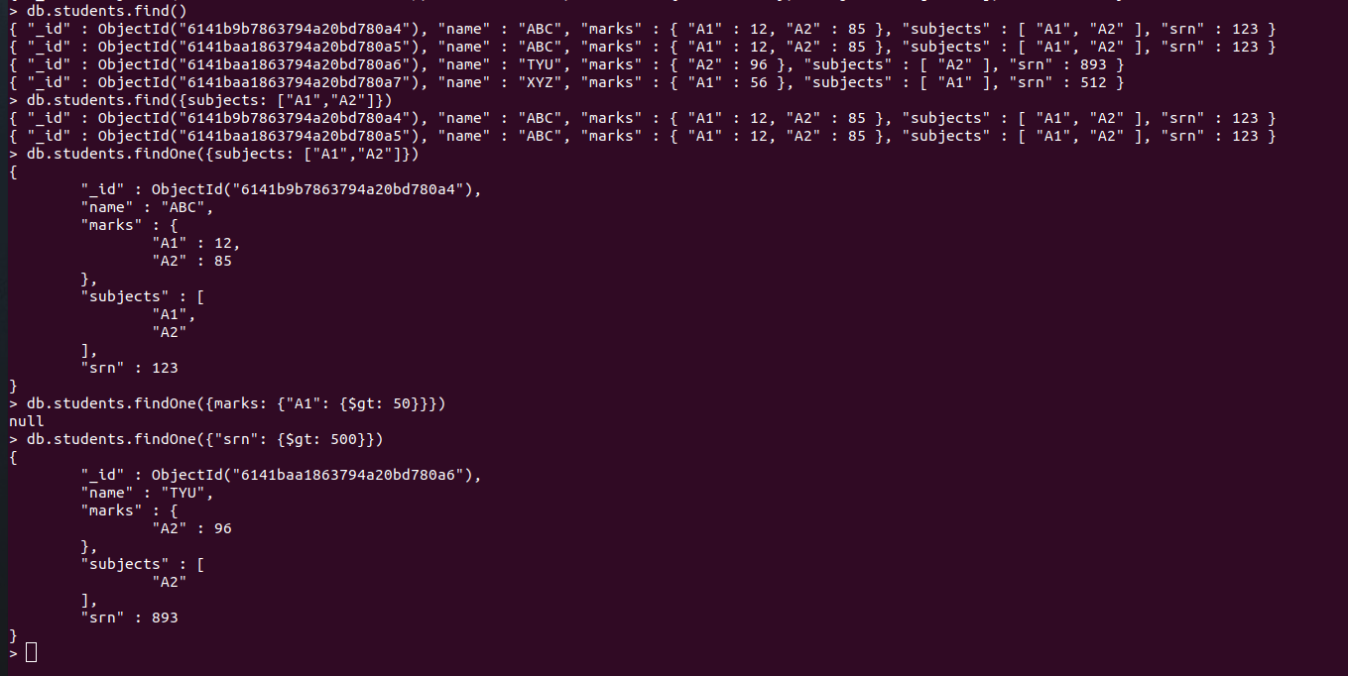

1. Using special operators in the filter. Eg: $gt matches all all the entries with value greater than specified value

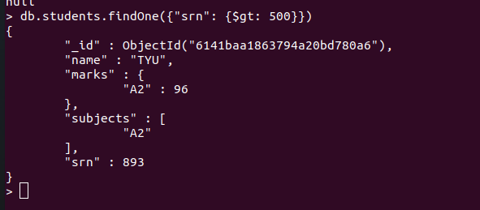

1. **UPDATE:**
2. Update an entry using update(filter, update_value)/updateOne(filter, update_value)

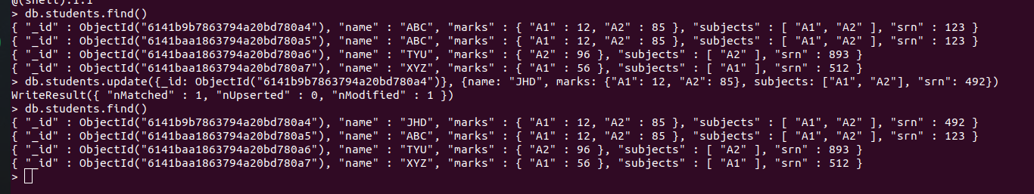

1. Update with upsert flag, which inserts a new record if no existing record matches the filter specified

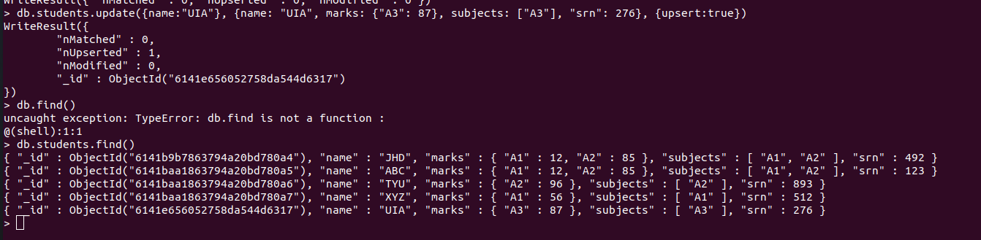

1. Update multiple records using updateMany(filter, update_value) and $set operator

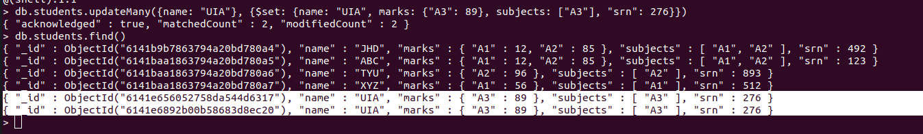

1. Replace a record in the db with a new record using replaceOne(filter, replace_value)

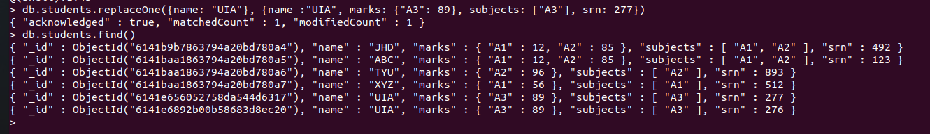

1. **DELETE:**
2. Delete a record from the db using deleteOne(filter)

Screenshot from 2021-09-15 18-07-356

1. Delete multiple records using deleteMany(filter)

